MINUTES FOR THE DECEMBER 4, 2002

Meeting started at 12:15
Visiting member from Ottawa West Mr. Keith Henry was introduced.
Robin Malloy was introduced by Brenda MacDonald-rowe
David McGlade introduced our newest member Anne Miklos.

Russ Hicks sent an email to David about the parade and talked for 5 minutes at his groups meeting.
Brian has been asked to put a spark under the towns butt and collect the tulip monies.
Roll Call, name and occupation.
Roy was asked about the Kettle schedule for the Salvation Army and stated we were short 2 people, and that we had collected around $300.00. More on that at the end of this report.
Stephen O’Keefe was thanked for the use of (THE GARAGE) to set up the float for the parade.
Thank You to all who helped on the float, Dan ( All the chairs and wood goodies) Brenda for her Garland and talent, Kirk , and the two crazy elves on the float.
David mentioned the plowing match and how we can make monies for working at the match.( More to follow)
Al Jones mentioned the Christmas Party to be held at Kelly’s Loft on Dec 19, 2002.
Brenda said Grace

Sean wins 50/50

ATTENTION ATTENTION
WE ARE HAVING JANNE ESTAY AND MARY LOU GREEN COME TO OUR MEETING ON WEDNESDAY TO TALK ABOUT THE BREAKFAST PROGRAM AT NORTRE DAME HIGH SCHOOL. WE ARE ALSO HAVING SUSAN KOLAR WHO IS THE ASSISTANT DEPUTY GOVERNOR . SHE WILL ANSWER ANY QUESTIONS THAT WE MAY HAVE ABOUT ANYTHING THAT WE NEED ANSWERS TO. PLEASE TRY TO BE AT THIS MEETING, AS I WILL ALSO BE GIVING A REPORT ON THE ROTARY CENTENNIAL PROJECT.
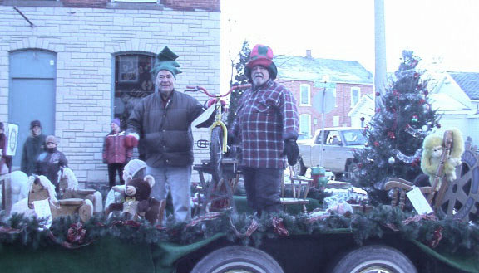
SANTA’S HELPERS ?????????

