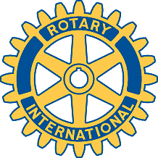

Rotary Club of Carleton Place and Mississippi Mills

Meeting of September 23rd, 2013

Louise Noble gave a presentation on the Lanark Alzheimers Society, and accepted a donation of $200 from the club.

