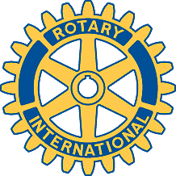

Rotary Club of Carleton Place and Mississippi Mills

Meeting of January 15 2018

Attendees: Marion, Brenda, Mike, Kathy, David, Ernie, Bernie, Deb, Mike B

Guest Speaker : Bruce Milks - RNJ Youth Services

Oh Canada, Prayer, Happy Dollars

Chase the Ace - $505.00 - woohoo - David pulled ticket ending with 382. Deb again !!! She pulled the 7 of Diamonds

Treasurer / Secretary Reports - Nothing new.

Casino night - committee meeting at 65 Munro St at 7 pm on Thursday Jan 18 / 18

Presentation - RNJ Youth Services - R = Rev, N = Norm, J = Johnston,
This is a Not for Profit organization to help youths aged 12 to 17.
There are offices in Smiths Falls and Brockville. Volunteers are needed to assist during the work day.

Meeting adjourned.

Club website : http://carletonplacerotary.ca

